<https://jhovious.github.io/team2cs334.github.io/>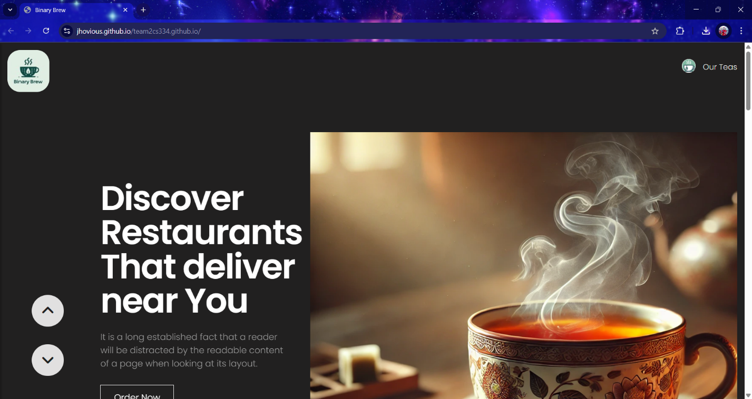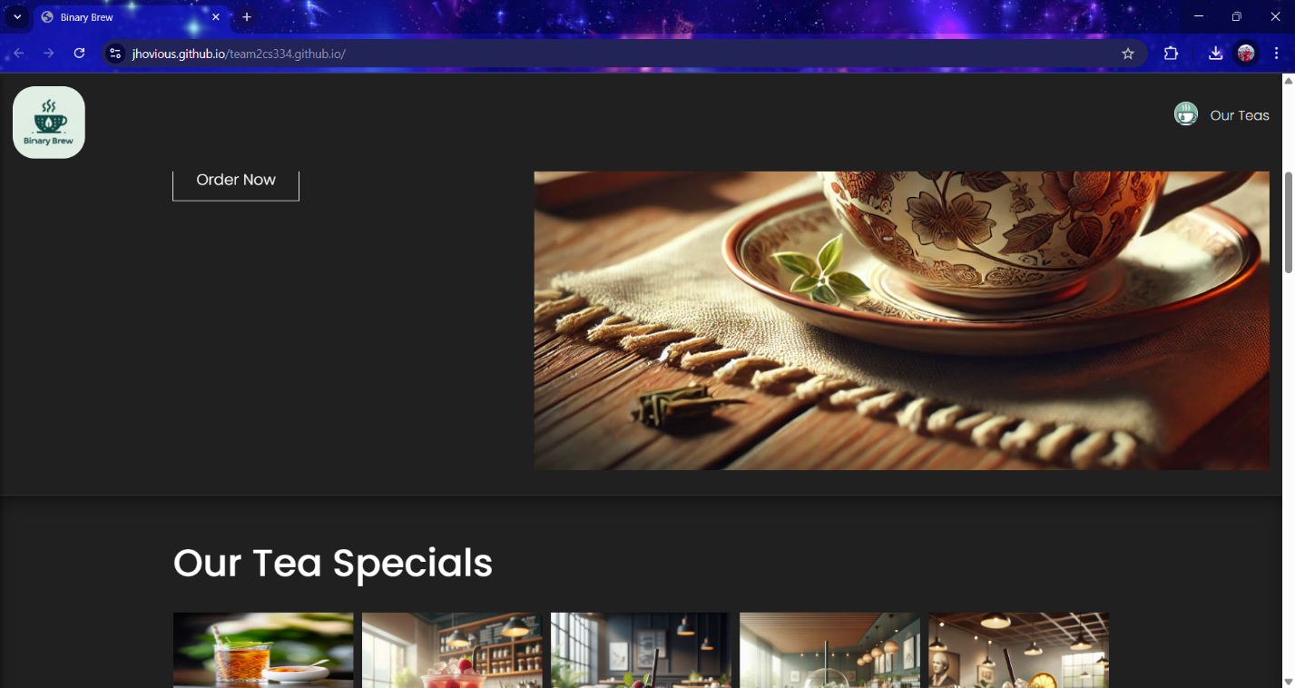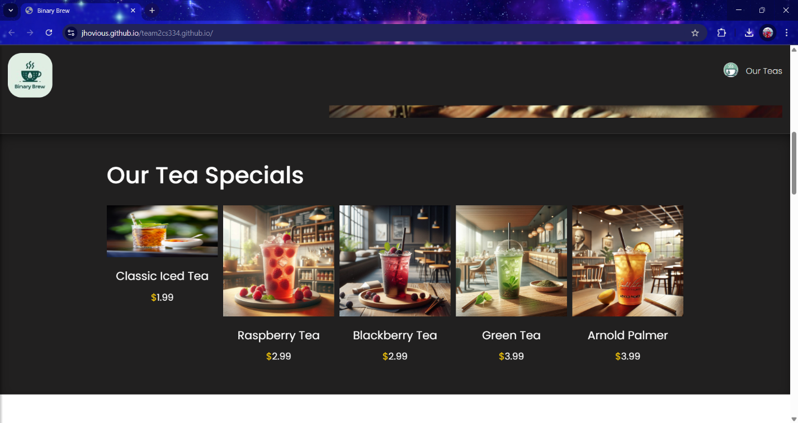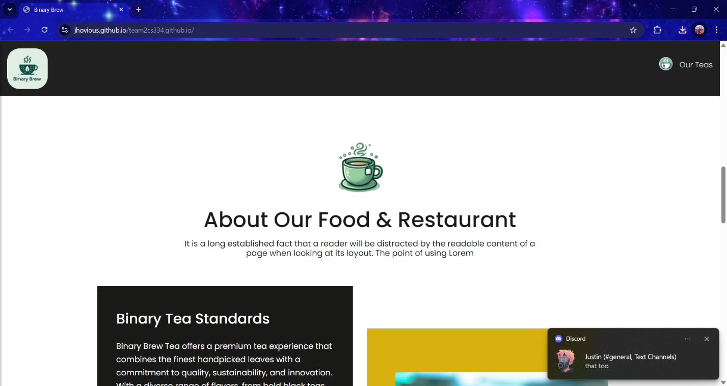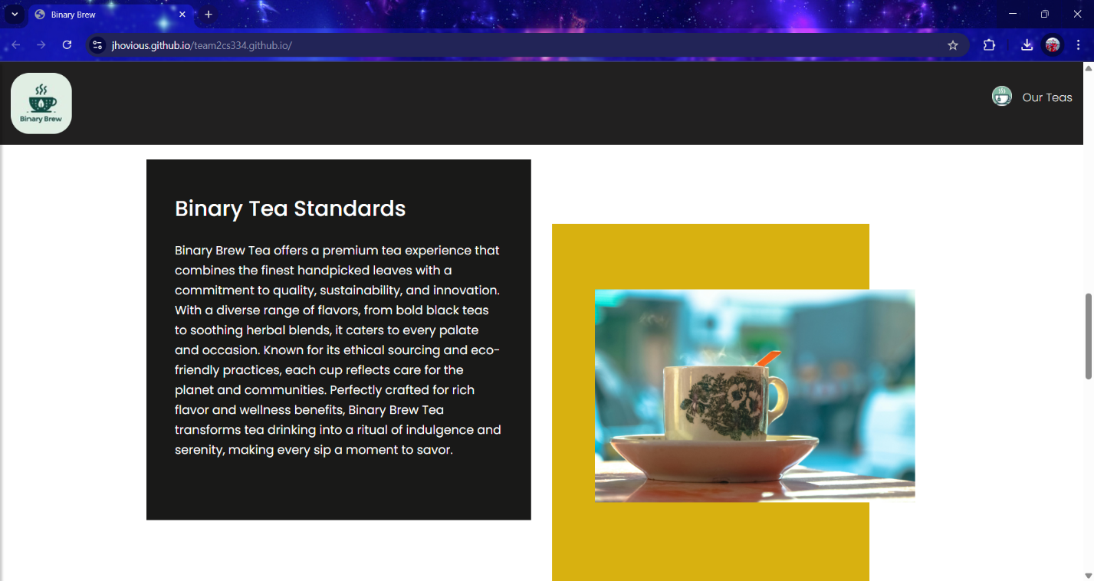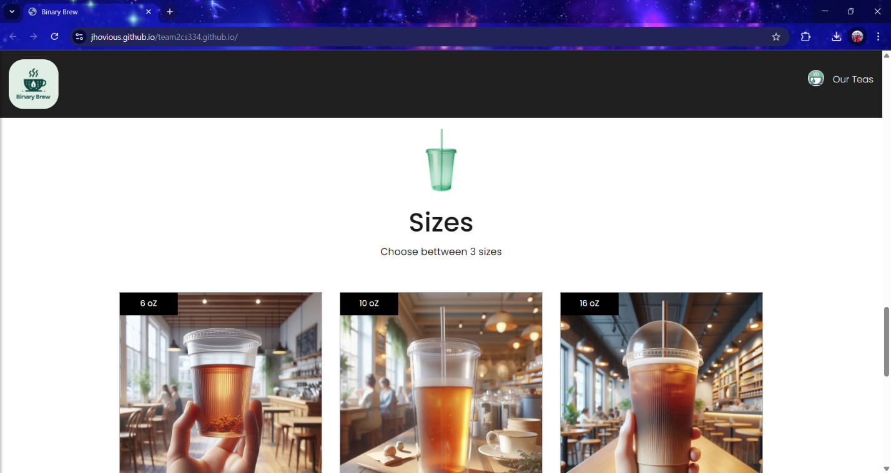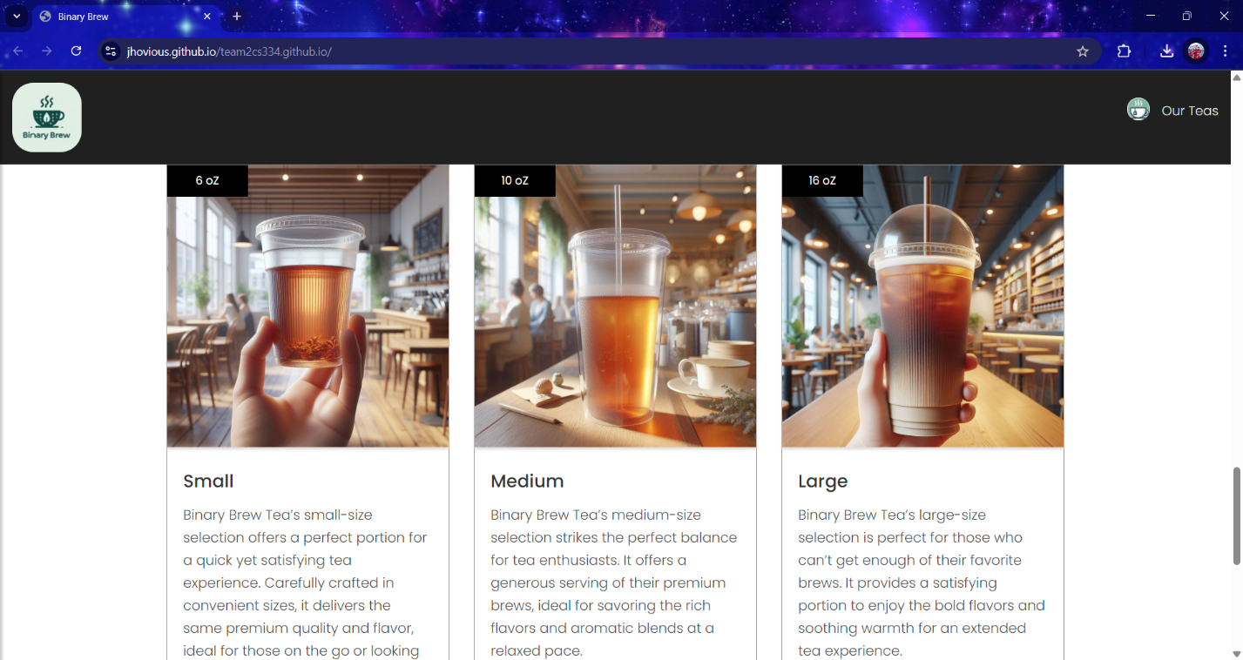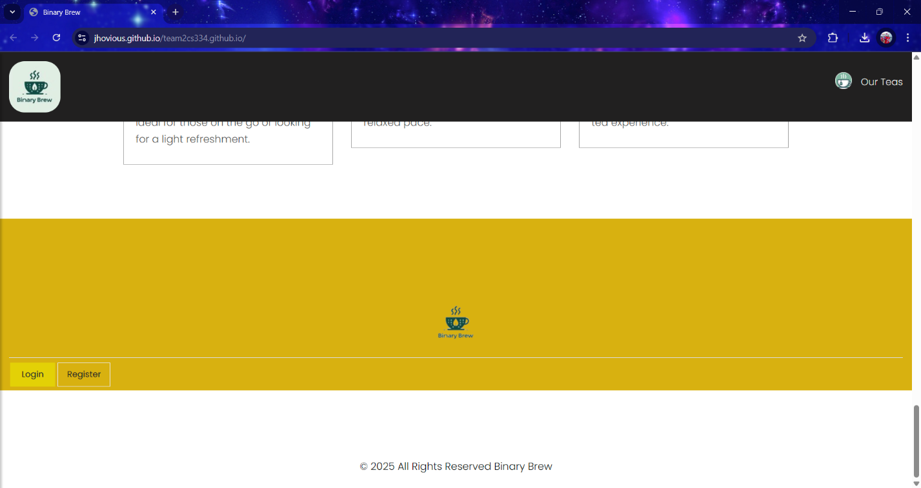

[https://jhovious.github.io/team2cs334.github.io/Part%202/templates/cart.html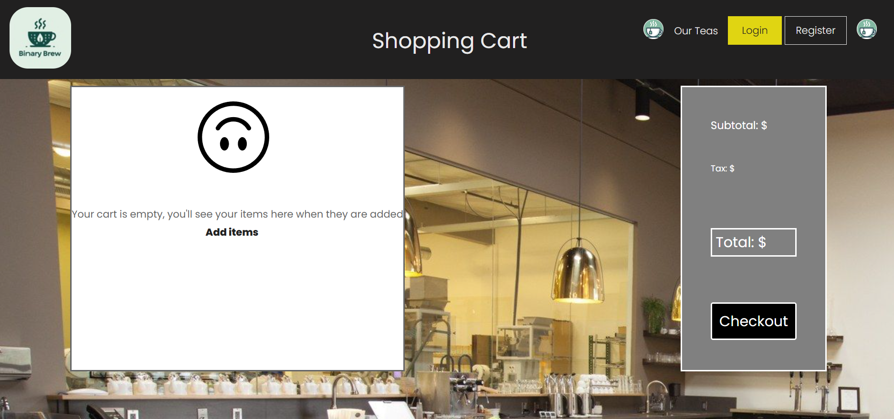](https://jhovious.github.io/team2cs334.github.io/Part%202/templates/cart.html)

<https://jhovious.github.io/team2cs334.github.io/Part%202/templates/contact-us.html>

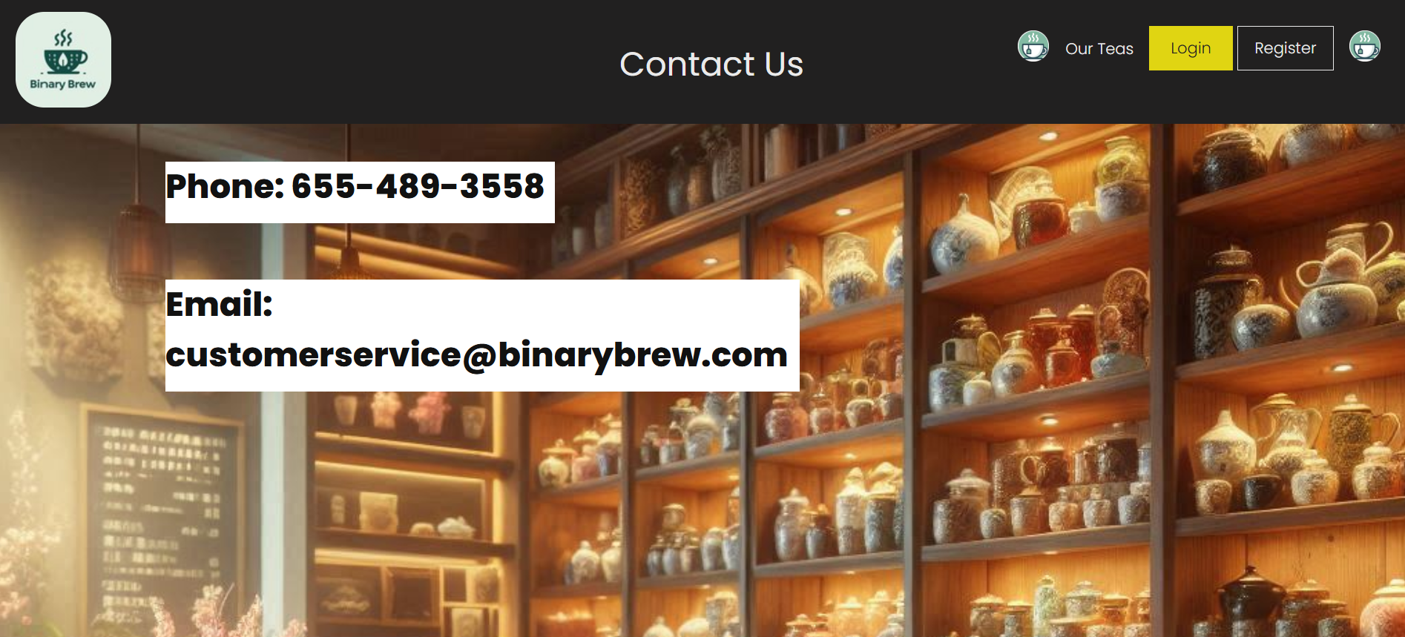

<https://jhovious.github.io/team2cs334.github.io/Part%202/templates/checkout.html>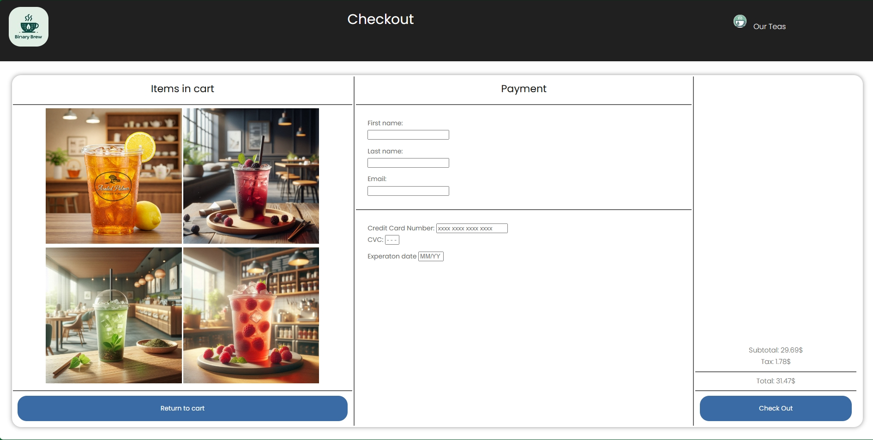

<https://jhovious.github.io/team2cs334.github.io/Part%202/templates/checkedout.html>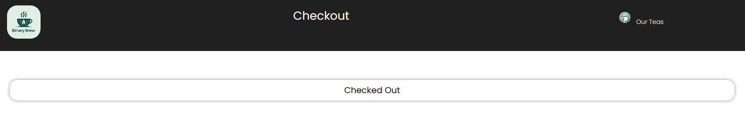

<https://jhovious.github.io/team2cs334.github.io/Part%202/templates/login.html>

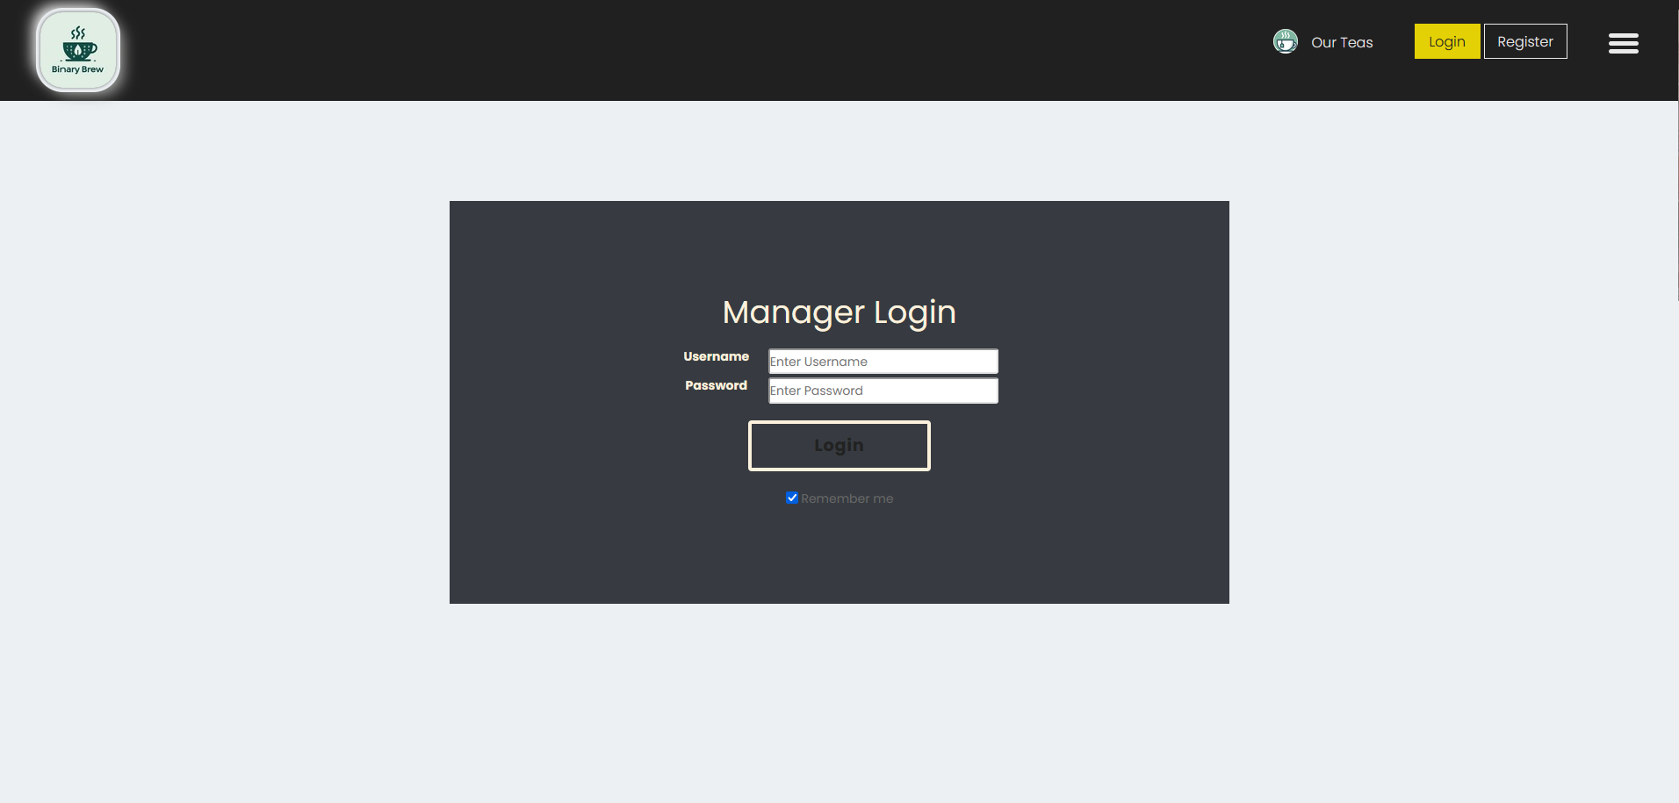

<https://jhovious.github.io/team2cs334.github.io/Part%202/templates/Manager_Menu.html>

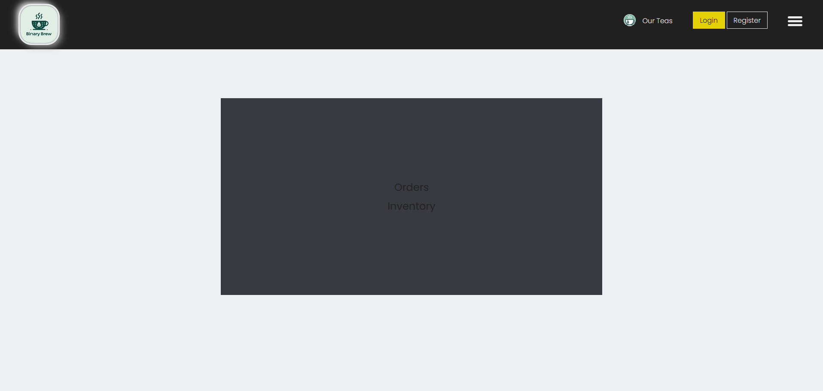

<https://jhovious.github.io/team2cs334.github.io/Part%202/templates/Orders.html>

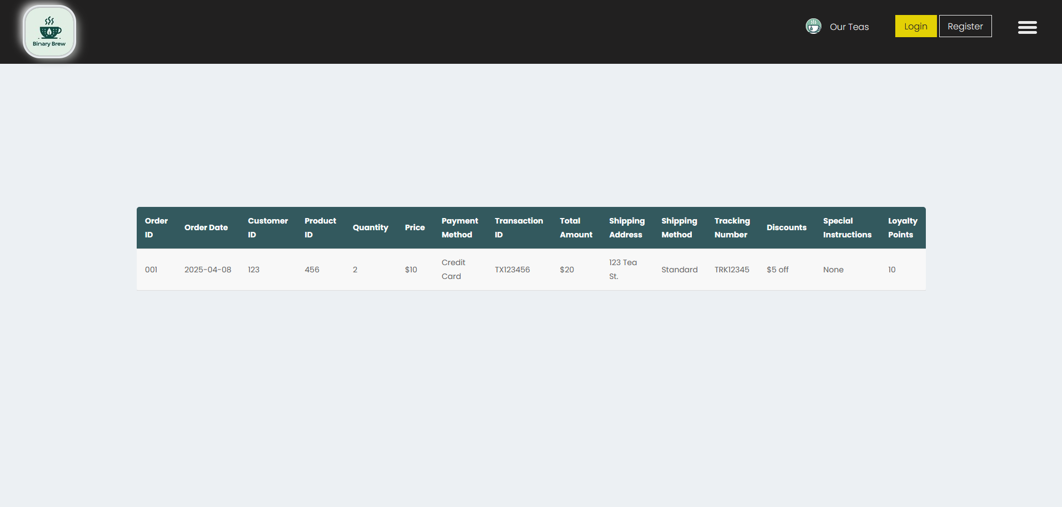

<https://jhovious.github.io/team2cs334.github.io/Part%202/templates/Inventory.html>

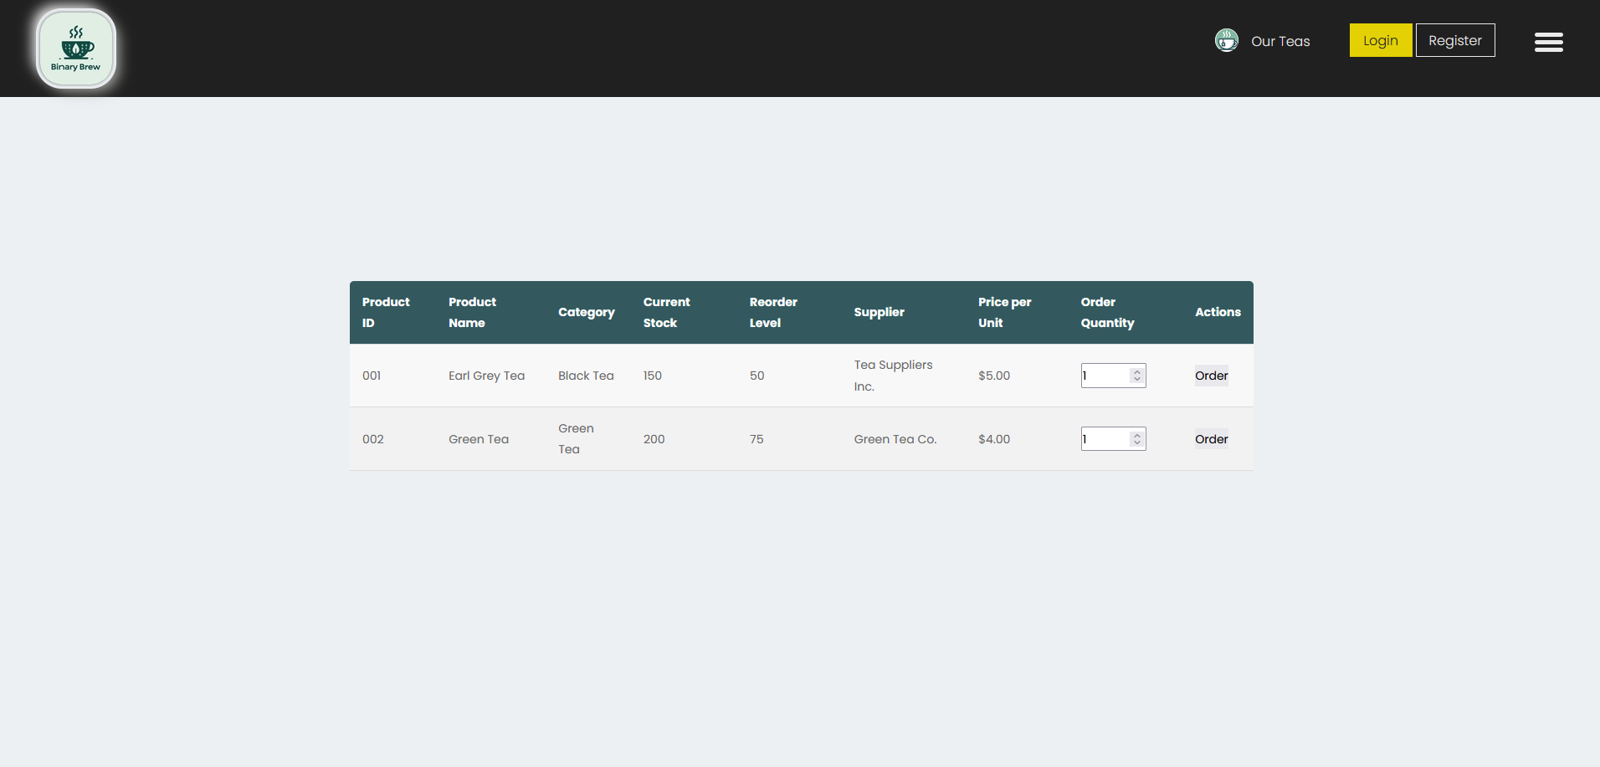

<https://jhovious.github.io/team2cs334.github.io/Part%202/templates/allTeas.html>

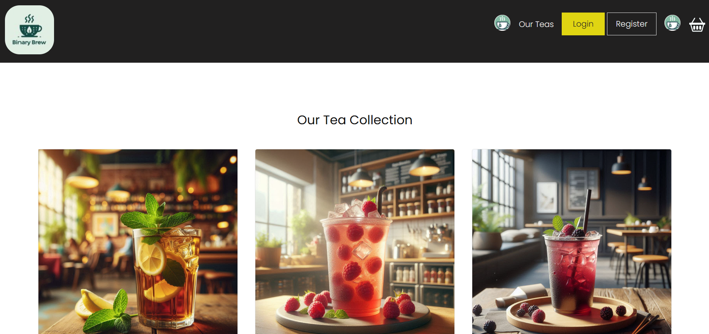

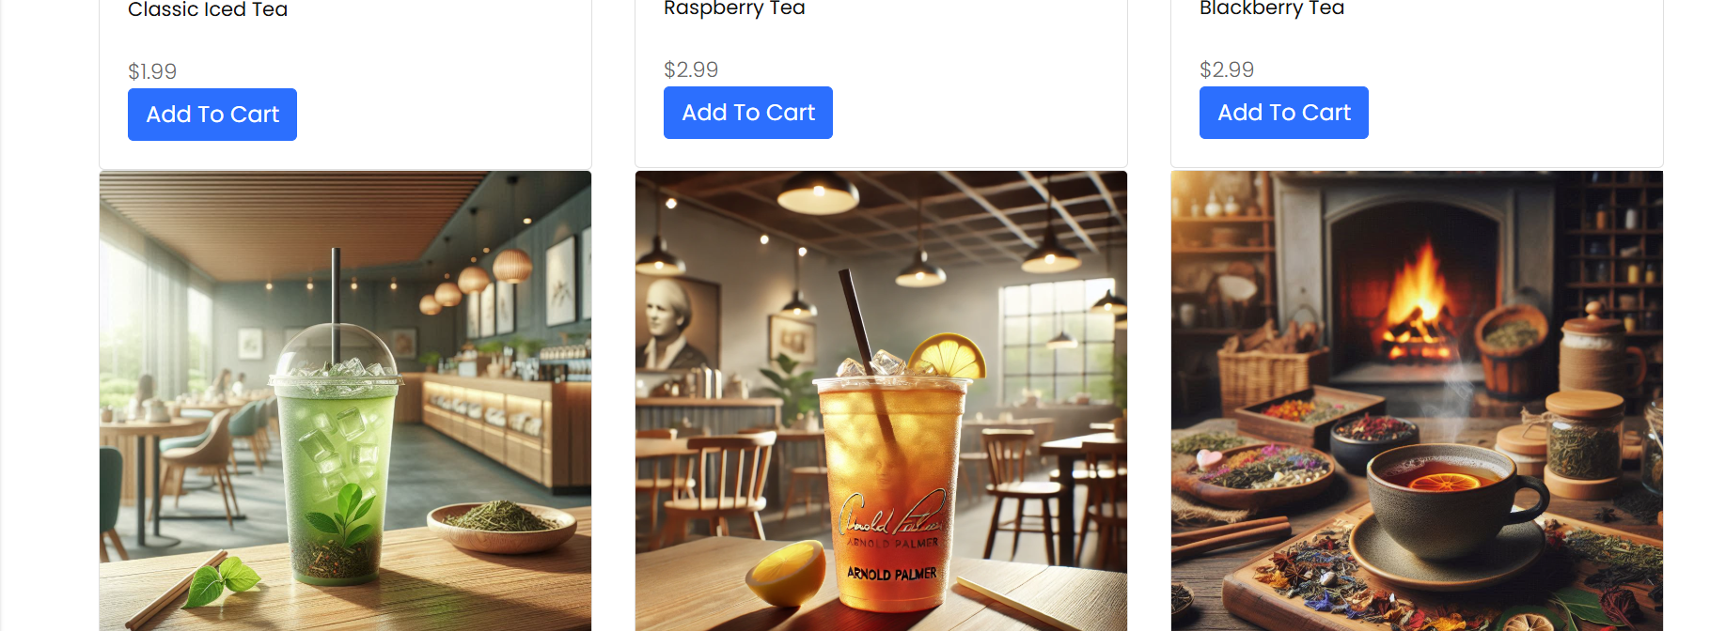

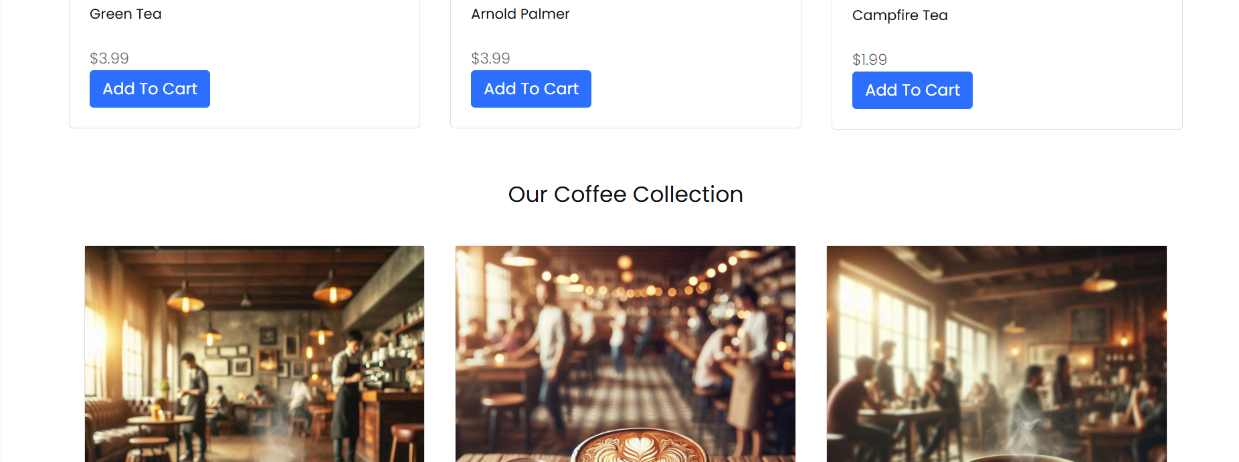

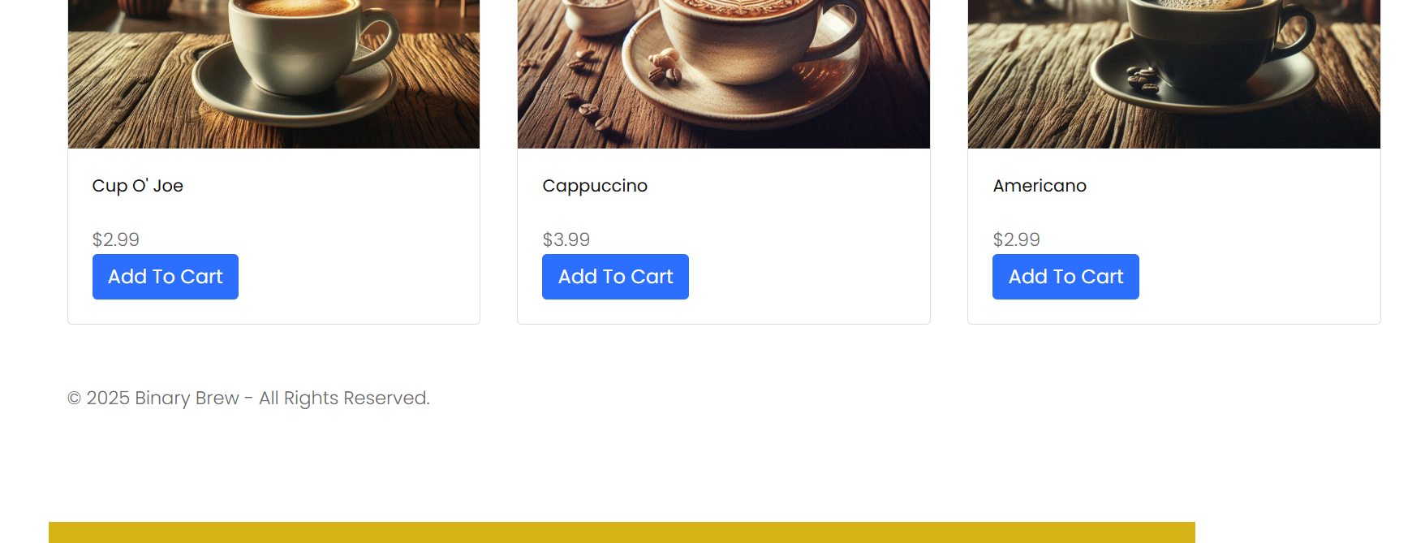

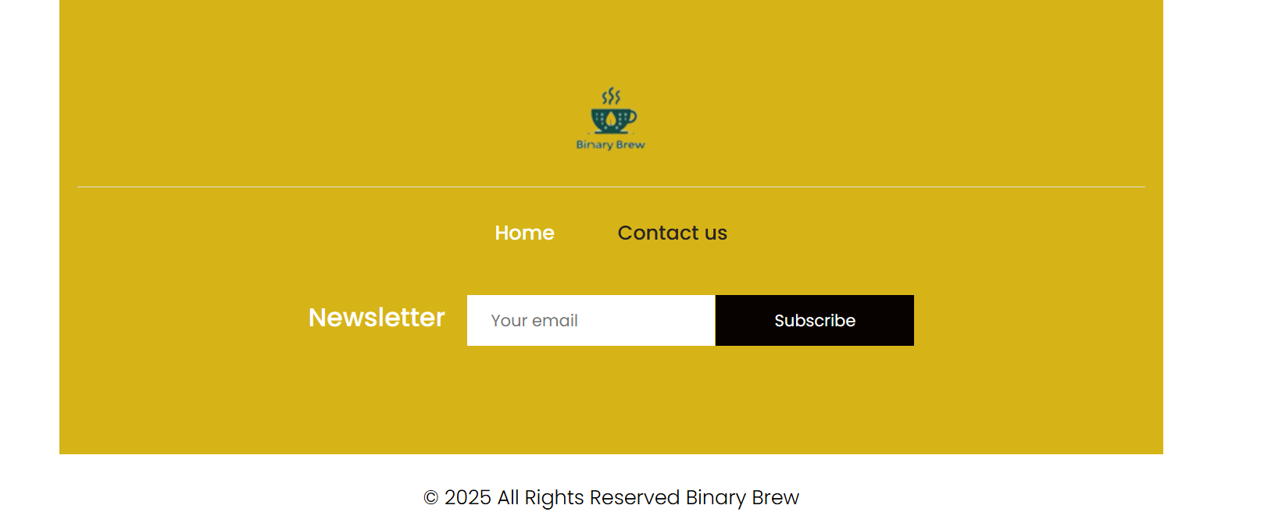

<https://jhovious.github.io/team2cs334.github.io/Part%202/templates/register.html>

